**Explore traceroute/tracert for different websites e.g.: google.com and analyze the parameters in the output and explore different options for traceroute command.**

The traceroute (Linux) or tracert (Windows) command helps analyze the path that packets take from your system to a destination (like google.com). It lists each hop (router) along the route, showing how data travels across networks.

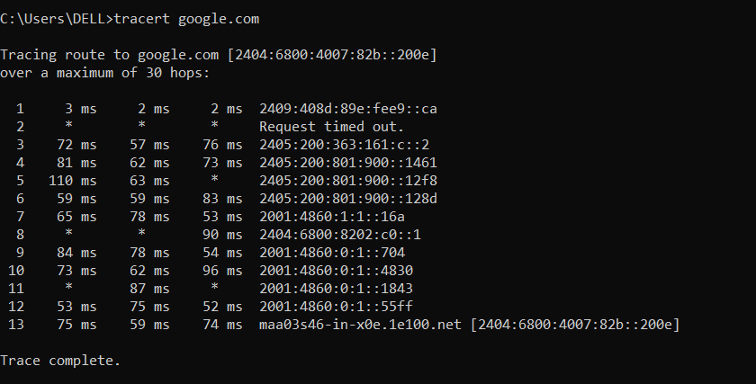

* **Hop Number** → Sequence number of each router the packet passes through.
* **Response Times (ms)** → Three round-trip times showing how long the packet takes to reach that router and return.
* **IP Address/Hostname** → Identifies the router at that hop (e.g., 2409:408d:89e:fee9::ca).
* **Request Timed Out (* * *)** → Indicates the router did not respond, possibly due to firewall rules or filtering.
* A single * in a hop (e.g., 110 ms 63 ms *) means that one of the three probe packets did not receive a response.
* **Final Hop** → The last hop shows the destination server (2404:6800:4007:82b::200e), confirming successful packet delivery.

**DIFFERENT OPTIONS:**

* **-h <max_hops>** → Set the maximum number of hops.

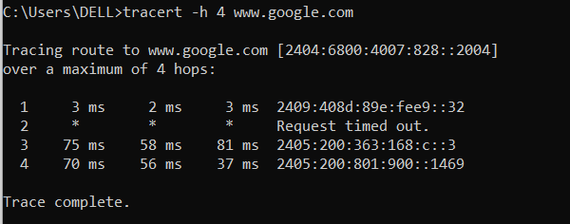

* **-w <timeout>** → Set the timeout for each hop (in milliseconds).

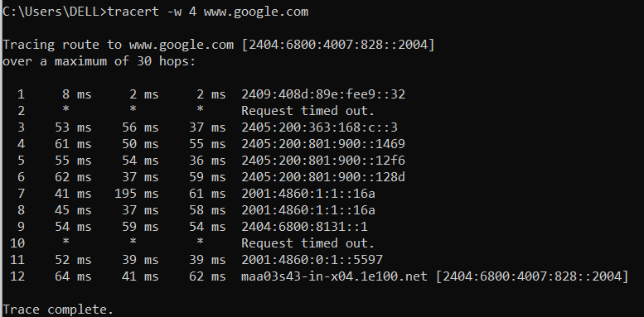

* **-4** → Force IPv4 tracing.

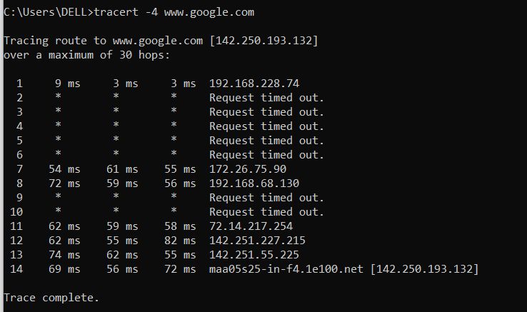

* **-6** → Force IPv6 tracing.

